**Collect Metrics from Exporters using the Managed Service for Prometheus**

experimentLabschedule1 hour 30 minutesuniversal\_currency\_alt1 Creditshow\_chartIntroductory

Rate Lab

**GSP1026**



**Overview**

In this lab, you will explore using the Managed Service for Prometheus to collect metrics from other infrastructure sources via exporters.

Objectives

In this lab, you will learn how to:

1. Deploy a GCE instance and configure the node-exporter tool
2. Build the GMP binary locally and deploy to the GCE instance
3. Apply a Prometheus configuration to begin collecting metrics

**Setup and requirements**

Before you click the Start Lab button

Read these instructions. Labs are timed and you cannot pause them. The timer, which starts when you click **Start Lab**, shows how long Google Cloud resources will be made available to you.

This hands-on lab lets you do the lab activities yourself in a real cloud environment, not in a simulation or demo environment. It does so by giving you new, temporary credentials that you use to sign in and access Google Cloud for the duration of the lab.

To complete this lab, you need:

* Access to a standard internet browser (Chrome browser recommended).

**Note:** Use an Incognito or private browser window to run this lab. This prevents any conflicts between your personal account and the Student account, which may cause extra charges incurred to your personal account.

* Time to complete the lab---remember, once you start, you cannot pause a lab.

**Note:** If you already have your own personal Google Cloud account or project, do not use it for this lab to avoid extra charges to your account.

How to start your lab and sign in to the Google Cloud console

1. Click the **Start Lab** button. If you need to pay for the lab, a pop-up opens for you to select your payment method. On the left is the **Lab Details** panel with the following:
   * The **Open Google Cloud console** button
   * Time remaining
   * The temporary credentials that you must use for this lab
   * Other information, if needed, to step through this lab
2. Click **Open Google Cloud console** (or right-click and select **Open Link in Incognito Window** if you are running the Chrome browser).

The lab spins up resources, and then opens another tab that shows the **Sign in** page.

***Tip:*** Arrange the tabs in separate windows, side-by-side.

**Note:**If you see the **Choose an account** dialog, click **Use Another Account**.

1. If necessary, copy the **Username** below and paste it into the **Sign in** dialog.

"Username"

Copied!

content\_copy

You can also find the **Username** in the **Lab Details** panel.

1. Click **Next**.
2. Copy the **Password** below and paste it into the **Welcome** dialog.

"Password"

Copied!

content\_copy

You can also find the **Password** in the **Lab Details** panel.

1. Click **Next**.

**Important:**You must use the credentials the lab provides you. Do not use your Google Cloud account credentials.**Note:**Using your own Google Cloud account for this lab may incur extra charges.

1. Click through the subsequent pages:
   * Accept the terms and conditions.
   * Do not add recovery options or two-factor authentication (because this is a temporary account).
   * Do not sign up for free trials.

After a few moments, the Google Cloud console opens in this tab.

**Note:** To view a menu with a list of Google Cloud products and services, click the **Navigation menu** at the top-left. 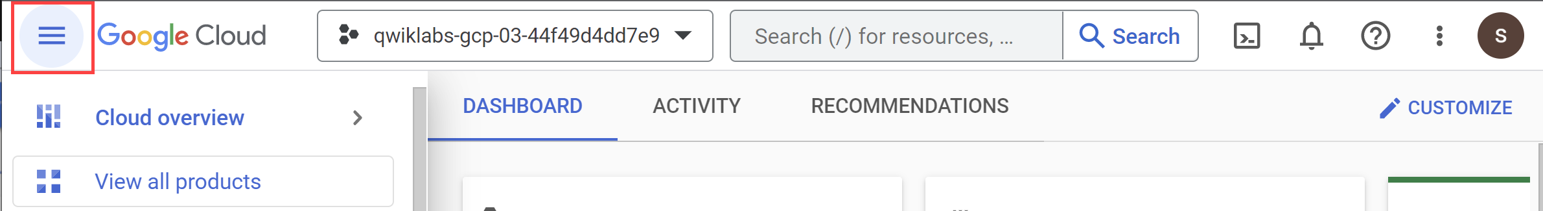

Activate Cloud Shell

Cloud Shell is a virtual machine that is loaded with development tools. It offers a persistent 5GB home directory and runs on the Google Cloud. Cloud Shell provides command-line access to your Google Cloud resources.

1. Click **Activate Cloud Shell** Activate Cloud Shell icon at the top of the Google Cloud console.

When you are connected, you are already authenticated, and the project is set to your **Project\_ID**, PROJECT\_ID. The output contains a line that declares the **Project\_ID** for this session:

Your Cloud Platform project in this session is set to "PROJECT\_ID"

gcloud is the command-line tool for Google Cloud. It comes pre-installed on Cloud Shell and supports tab-completion.

1. (Optional) You can list the active account name with this command:

gcloud auth list

Copied!

content\_copy

1. Click **Authorize**.

**Output:**

ACTIVE: \*

ACCOUNT: "ACCOUNT"

To set the active account, run:

$ gcloud config set account `ACCOUNT`

1. (Optional) You can list the project ID with this command:

gcloud config list project

Copied!

content\_copy

**Output:**

[core]

project = "PROJECT\_ID"

**Note:**For full documentation of gcloud, in Google Cloud, refer to [the gcloud CLI overview guide](https://cloud.google.com/sdk/gcloud).

**Task 1. Deploy GKE cluster**

* Deploy a basic GKE cluster to set up the lab:

gcloud beta container clusters create gmp-cluster --num-nodes=1 --zone Zone --enable-managed-prometheus

Copied!

content\_copy

gcloud container clusters get-credentials gmp-cluster --zone=Zone

Copied!

content\_copy

**Task 2. Set up a namespace**

* Create the gmp-test Kubernetes namespace for resources you create as part of the example application:

kubectl create ns gmp-test

Copied!

content\_copy

Check if prometheus has been deployed

Check my progress

**Task 3. Deploy the example application**

The managed service provides a manifest for an example application that emits Prometheus metrics on its metrics port. The application uses three replicas.

* To deploy the example application, run the following command:

kubectl -n gmp-test apply -f https://raw.githubusercontent.com/GoogleCloudPlatform/prometheus-engine/v0.2.3/examples/example-app.yaml

Copied!

content\_copy

**Task 4. Configure a PodMonitoring resource**

To ingest the metric data emitted by the example application, you use target scraping. Target scraping and metrics ingestion are configured using Kubernetes [custom resources](https://kubernetes.io/docs/concepts/extend-kubernetes/api-extension/custom-resources/). The managed service uses [PodMonitoring](https://github.com/GoogleCloudPlatform/prometheus-engine/blob/v0.2.3/doc/api.md" \l "podmonitoring" \t "_blank) custom resources (CRs).

A PodMonitoring CR scrapes targets only in the namespace the CR is deployed in. To scrape targets in multiple namespaces, deploy the same PodMonitoring CR in each namespace. You can verify the PodMonitoring resource is installed in the intended namespace by running kubectl get podmonitoring -A.

For reference documentation about all the Managed Service for Prometheus CRs, see the [prometheus-engine/doc/api reference](https://github.com/GoogleCloudPlatform/prometheus-engine/blob/v0.2.3/doc/api.md" \t "_blank).

The following manifest defines a PodMonitoring resource, prom-example, in the gmp-test namespace. The resource uses a [Kubernetes label selector](https://kubernetes.io/docs/concepts/overview/working-with-objects/labels/) to find all pods in the namespace that have the label app with the value prom-example. The matching pods are scraped on a port named metrics, every 30 seconds, on the /metrics HTTP path.

apiVersion: monitoring.googleapis.com/v1alpha1

kind: PodMonitoring

metadata:

name: prom-example

spec:

selector:

matchLabels:

app: prom-example

endpoints:

- port: metrics

interval: 30s

Copied!

content\_copy

* To apply this resource, run the following command:

kubectl -n gmp-test apply -f https://raw.githubusercontent.com/GoogleCloudPlatform/prometheus-engine/v0.2.3/examples/pod-monitoring.yaml

Copied!

content\_copy

Your managed collector is now scraping the matching pods.

To configure horizontal collection that applies to a range of pods across all namespaces, use the [ClusterPodMonitoring](https://github.com/GoogleCloudPlatform/prometheus-engine/blob/v0.2.3/doc/api.md" \l "clusterpodmonitoring" \t "_blank) resource. The ClusterPodMonitoring resource provides the same interface as the PodMonitoring resource but does not limit discovered pods to a given namespace.

**Note**: An additional targetLabels field provides a simplified Prometheus-style [relabel configuration](https://prometheus.io/docs/prometheus/latest/configuration/configuration/#relabel_config). You can use relabeling to add pod labels as labels on the ingested time series. You can't overwrite the mandatory target labels; for a list of these labels, see the [prometheus\_target resource](https://cloud.google.com/stackdriver/docs/managed-prometheus/query" \l "target-resource" \t "_blank).

If you are running on GKE, then you can do the following:

* To query the metrics ingested by the example application, see Query data from the Prometheus service.
* To learn about filtering exported metrics and adapting your prom-operator resources, see Additional topics for managed collection.

**Task 5. Download the prometheus binary**

* Download the prometheus binary from the following bucket:

git clone https://github.com/GoogleCloudPlatform/prometheus && cd prometheus

Copied!

content\_copy

git checkout v2.28.1-gmp.4

Copied!

content\_copy

wget https://storage.googleapis.com/kochasoft/gsp1026/prometheus

Copied!

content\_copy

chmod a+x prometheus

Copied!

content\_copy

**Task 6. Run the prometheus binary**

1. Save your project id to a variable:

export PROJECT\_ID=$(gcloud config get-value project)

Copied!

content\_copy

1. Save your zone to a variable. These values will be used when running your promtheus binary.

export ZONE=Zone

Copied!

content\_copy

1. Run the prometheus binary on cloud shell using command here:

./prometheus \

--config.file=documentation/examples/prometheus.yml --export.label.project-id=$PROJECT\_ID --export.label.location=$ZONE

Copied!

content\_copy

After the prometheus binary begins you should be able to go to managed prometheus in the Console UI and run a PromQL query “up” to see the prometheus binary is available (will show localhost running one as the instance name).

**Task 7. Download and run the node exporter**

1. Open a new tab in cloud shell to run the node exporter commands.
2. Download and run the exporter on the cloud shell box:

wget https://github.com/prometheus/node\_exporter/releases/download/v1.3.1/node\_exporter-1.3.1.linux-amd64.tar.gz

Copied!

content\_copy

tar xvfz node\_exporter-1.3.1.linux-amd64.tar.gz

Copied!

content\_copy

cd node\_exporter-1.3.1.linux-amd64

Copied!

content\_copy

./node\_exporter

Copied!

content\_copy

**Note**: The port that the node\_exporter tool is running on you will use to modify the config of prometheus on the next few steps.

You should see output like this indicating that the Node Exporter is now running and exposing metrics on port 9100:

ts=2023-03-01T10:27:17.262Z caller=node\_exporter.go:199 level=info msg="Listening on" address=:9100

ts=2023-03-01T10:27:17.263Z caller=tls\_config.go:195 level=info msg="TLS is disabled." http2=false

Create a config.yaml file

1. Stop the running prometheus binary in the 1st tab of Cloud Shell and have a new config file which will take the metrics from node exporter:

vi config.yaml

Copied!

content\_copy

1. Create a config.yaml file with the following spec:

global:

scrape\_interval: 15s

scrape\_configs:

- job\_name: node

static\_configs:

- targets: ['localhost:9100']

Copied!

content\_copy

1. Upload the config.yaml file you created to verify:

export PROJECT=$(gcloud config get-value project)

Copied!

content\_copy

gsutil mb -p $PROJECT gs://$PROJECT

Copied!

content\_copy

gsutil cp config.yaml gs://$PROJECT

Copied!

content\_copy

gsutil -m acl set -R -a public-read gs://$PROJECT

Copied!

content\_copy

Check if config.yaml is configured correctly

Check my progress

1. Re-run prometheus pointing to the new configuration file by running the command below:

./prometheus --config.file=config.yaml --export.label.project-id=$PROJECT --export.label.location=$ZONE

Copied!

content\_copy

1. Use the following stat from the exporter to see its count in a PromQL query. In Cloud Shell, click on the web preview icon. Set the port to 9090 by selecting **Change Preview Port** and preview by clicking **Change and Preview**.

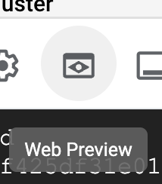

Write any query in the PromQL query Editor prefixed with **“node\_”** this should bring up an input list of metrics you can select to visualize in the graphical editor.

* "node\_cpu\_seconds\_total" provides graphical data.

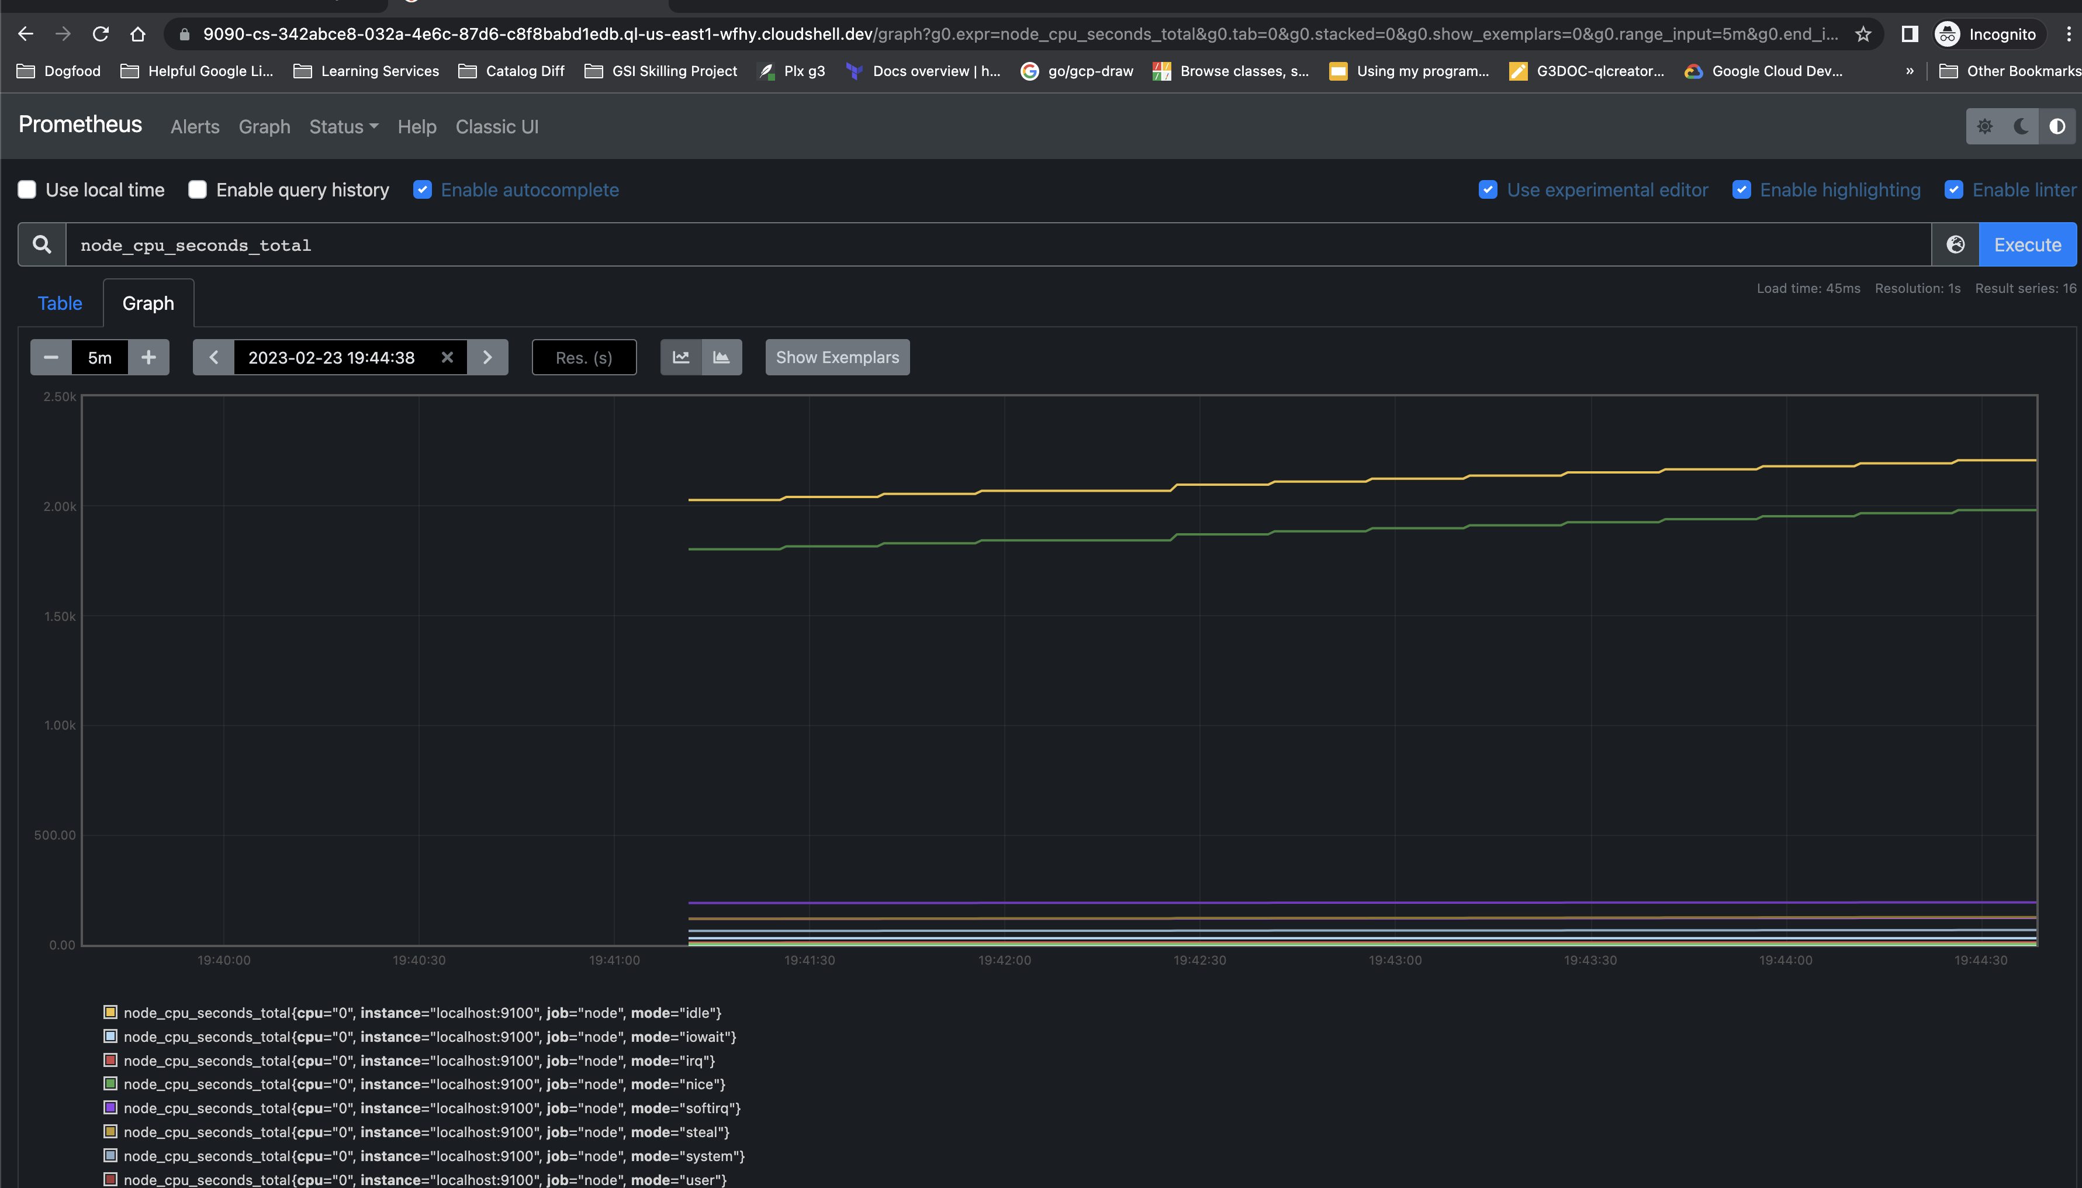

Try selecting other metrics that appear to view the data exported.

**Congratulations!**

In this lab you deployed a Compute Instance and configured node-exporter. You then configured the GMP binary to ingest metrics from node-exporter and viewed the metrics.

Finish your quest

This self-paced lab is part of the [Monitor Environments with Google Cloud managed Service for Prometheus](https://www.cloudskillsboost.google/quests/197) skill badge quest. A quest is a series of related labs that form a learning path. Completing this quest earns you a badge to recognize your achievement. You can make your badge or badges public and link to them in your online resume or social media account. [Enroll in this quest](https://www.cloudskillsboost.google/quests/197/enroll) and get immediate completion credit. Refer to the [Google Cloud Skills Boost catalog](http://cloudskillsboost.google/catalog) for all available quests.

Next steps / Learn more

You can read more about [Google cloud Managed Service for Prometheus](https://cloud.google.com/stackdriver/docs/managed-prometheus).

Google Cloud training and certification

...helps you make the most of Google Cloud technologies. [Our classes](https://cloud.google.com/training/courses) include technical skills and best practices to help you get up to speed quickly and continue your learning journey. We offer fundamental to advanced level training, with on-demand, live, and virtual options to suit your busy schedule. [Certifications](https://cloud.google.com/certification/) help you validate and prove your skill and expertise in Google Cloud technologies.

**Manual Last Updated October 27, 2023**

**Lab Last Tested October 27, 2023**

Copyright 2023 Google LLC All rights reserved. Google and the Google logo are trademarks of Google LLC. All other company and product names may be trademarks of the respective companies with which they are associated.

[navigate\_beforePrevious](https://www.cloudskillsboost.google/course_sessions/15064590/labs/408509)[Nextnavigate\_next](https://www.cloudskillsboost.google/course_sessions/15064590/labs/408511)